4. Binary Search with Big-O Analysis

Aim

To implement the Binary Search algorithm and analyze its time complexity using Big-O notation.

Algorithm

Start.

Initialize low = 0 and high = n - 1.

Calculate the middle index: mid = (low + high) // 2.

If the middle element equals the search key, display the element's position.

If the search key is smaller than the middle element, set high = mid - 1.

Otherwise, set low = mid + 1.

Repeat steps 3–6 while low <= high.

If the element is not found, display "Element not found."

Stop.

Procedure
- Start.
- Initialize low = 0 and high = n - 1.
- Calculate the middle index: mid = (low + high) // 2.
- If the middle element equals the search key, display the element's position.
- If the search key is smaller than the middle element, set high = mid - 1.
- Otherwise, set low = mid + 1.
- Repeat steps 3–6 while low <= high.
- If the element is not found, display "Element not found."
- Stop.

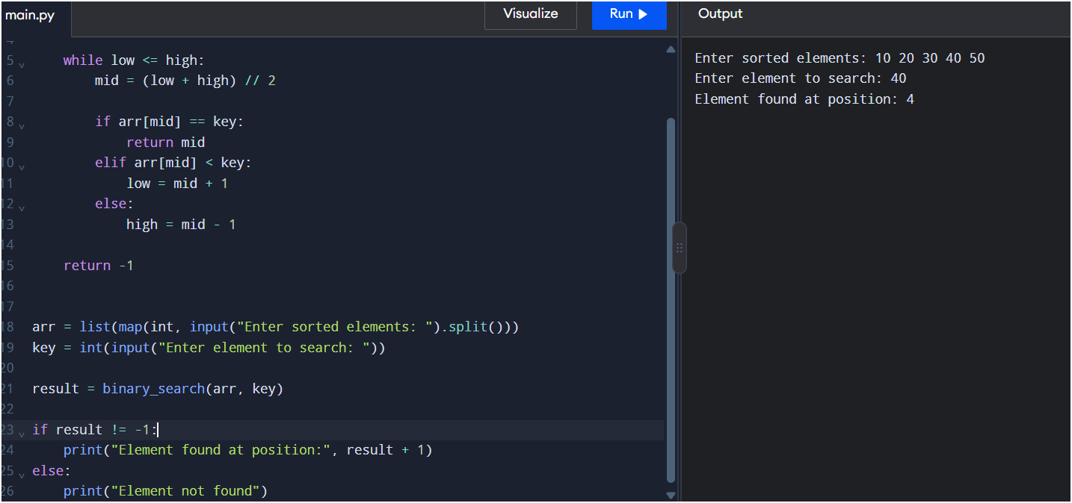

Result
Thus, the Binary Search algorithm was implemented successfully, and its time complexity was analyzed using Big-O notation.

